|  |
| --- |
|  |
| Capstone Project Document |

**WingS**

Report #2 – Data Design

|  |  |  |
| --- | --- | --- |
| **WingS** | | |
| **Group Members** | Đào Trọng Nghĩa | SE03220 |
| Lê Hồng Nhiên | SE03377 |
| Tạ Ngọc Duy | SE03267 |
| Đỗ Văn Tuấn | SE03297 |
| Hoàng Anh Tuấn | SE03108 |
| **Supervisor** | Mr. Nguyễn Văn Sang | |
| **Project code** | WS | |

**- Hanoi, 10/2016 –**

# SIGNATURE PAGE

AUTHOR: Tạ Ngọc Duy 08/10/2016

Team member

REVIEWERS: Đào Trọng Nghĩa --/--/2016

Project manager

APPROVAL: Nguyễn Văn Sang --/--/2016

Supervisor

Record of change

*A - Added M - Modified D – Deleted

|  |  |  |  |  |  |
| --- | --- | --- | --- | --- | --- |
| Effective Date | Changed Item | A,M,D | Change Description | Reason for Change | Rev. Number |
| 08/October/2016 | Create Data Design | A | Create Data Design | First version | 1.0 |
|  |  |  |  |  |  |
|  |  |  |  |  |  |
|  |  |  |  |  |  |
|  |  |  |  |  |  |
|  |  |  |  |  |  |
|  |  |  |  |  |  |
|  |  |  |  |  |  |
|  |  |  |  |  |  |
|  |  |  |  |  |  |
|  |  |  |  |  |  |
|  |  |  |  |  |  |
|  |  |  |  |  |  |
|  |  |  |  |  |  |
|  |  |  |  |  |  |
|  |  |  |  |  |  |
|  |  |  |  |  |  |
|  |  |  |  |  |  |
|  |  |  |  |  |  |
|  |  |  |  |  |  |
|  |  |  |  |  |  |
|  |  |  |  |  |  |
|  |  |  |  |  |  |
|  |  |  |  |  |  |

Table Contents

SIGNATURE PAGE 1

1 INTRODUCTION 3

1.1 Purpose 3

1.2 Acronyms and Definitions 3

1.3 References 3

1.4 Overview 3

2 Database 4

2.1 Entity Relationship Diagram 4

2.1.1 Entity Relationship Diagram 5

2.1.2 Relationship 5

2.2 Table Diagram 7

2.2.1 User table 8

2.2.2 UserInformation table 8

2.2.3 Event table 9

2.2.4 Organization table 10

2.2.5 Category table 10

2.2.6 ReportEvent table 11

2.2.7 FollowEvent table 11

2.2.8 Donate table 11

2.2.9 CommentEvent table 12

2.2.10 ReportUser table 12

2.2.11 Thread table 13

2.2.12 CommentThread table 13

2.2.13 ReportThread table 14

2.2.14 FollowThread table 14

# INTRODUCTION

## Purpose

Fly Away Plus data design document describes structure of database and file structure of system including internal file structure as well as interface file structure.

## Acronyms and Definitions

|  |  |
| --- | --- |
| **Acronym & Abbreviation** | **Definition** |
| WS | WingS |
| FU | FPT University |
| Q&A | Question and Answer |

Table 1‑1: Acronyms and Definitions

## References

|  |  |
| --- | --- |
| **Document** | **Title** |
| Class Design Document | WS_Class Design_v1.0_EN |
| Architecture Design | WS_Architecture Design_v1.0_EN |
| Software Requirement Specification | WS_Software Requirement Specification_v1.0_EN |

Table 1‑2: References

## Overview

This document describes relationship between entities and properties of each entity.

# Database

## Entity Relationship Diagram

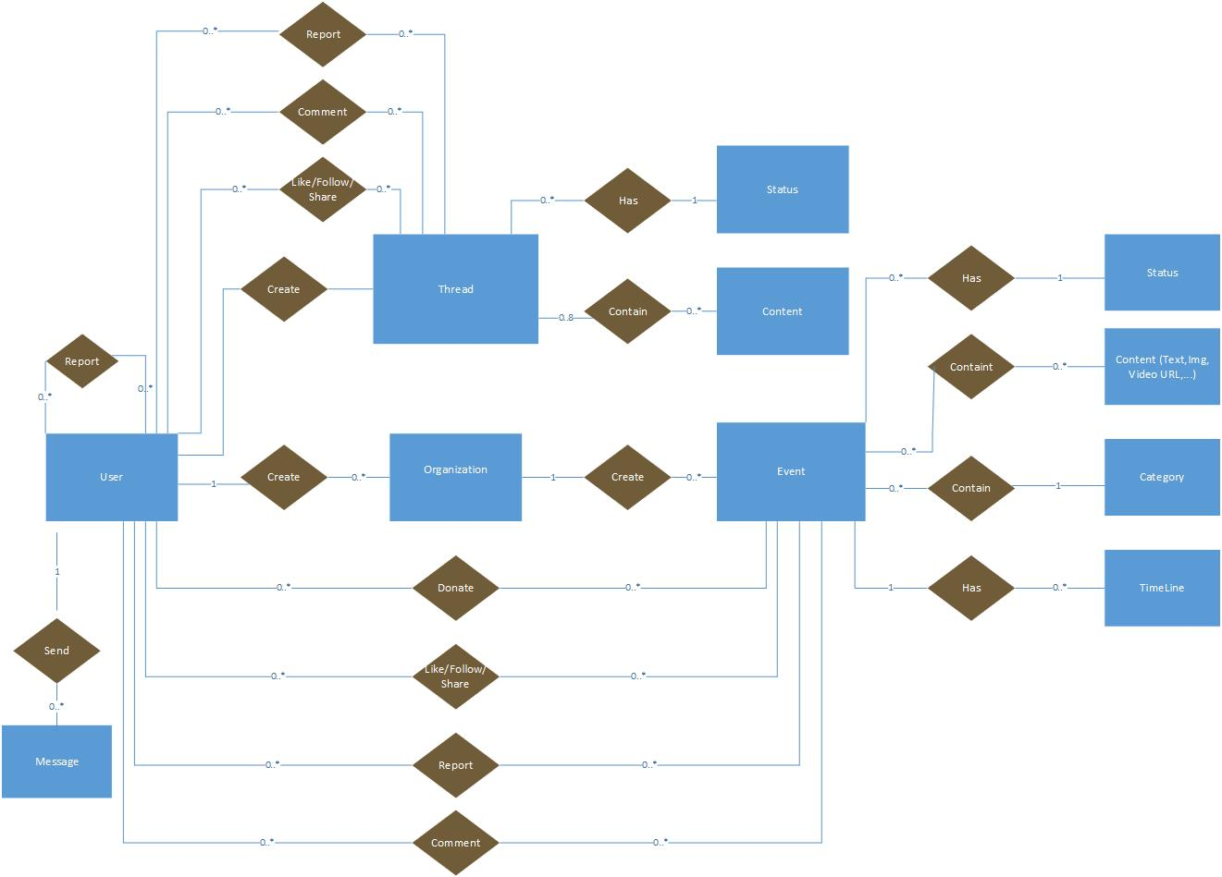

**Figure 2‑1:** Entity Relationship Diagram

### Entity description

|  |  |  |
| --- | --- | --- |
| **No** | **Entity** | **Description** |
|  | WS_User | User is all people who using WS feature |
|  | Event | An event which user created, includes content, schedule, photo, video to descripting. |
|  | Time Line | Timeline detail of an event. |
|  | Category | A category which user use to filter event |
|  | Organization | An organization can be created by an user (If user or group qualify). Only group can create event |
|  | Thread | Post of user created. Where all user can discussion. |
|  | Status | A status of Event or Thread. Active or be banned. |
|  | Conversation | A Conversation which user created and joined to send and receive message together |
|  | Message | A Message which user send or receive to talk together |

**Table 2-3:** Entity description

### Relationship

|  |  |  |  |  |  |
| --- | --- | --- | --- | --- | --- |
| **No** | **Relation** | **Properties** | **From** | **To** | **Description** |
|  | CONTAINS | None | Category | Event | A category contains many Event |
|  | HAS | None | Status | Event | A status contains many Event |
|  | HAS | None | Project | TimeLine | A event has one or more timelines, describe the detail of event |
|  | CONTAINS | None | Event | Content | An event contains many content (picture, text, video url…) |
|  | CREATE | None | User | Organization | An user can create organization if they want create event or group other users who have same idea. |
|  | CREATE | None | Organization | Event | An organization can create one or more event |
|  | COMMENT | UserID  EventID | User | Event | A Comment which user give to event |
|  | DONATE | UserID  EventID | User | Event | A event which user donate |
|  | FOLLOW | UserID  EventID | User | Event | A Remind which user bookmark an Event. |
|  | REPORT | UserID  EventID | User | Event | A Report which user report an Event |
|  | CONTAINS | None | Thread | Content | A thread contains many content (picture, text, video url…) |
|  | HAS | None | Status | Thread | A status contains many thread |
|  | CREATE | None | User | Thread | An user can create one or more thread |
|  | COMMENT | UserID  ThreadID | User | Thread | A Comment which user give to thread |
|  | FOLLOW | UserID  ThreadID | User | Thread | A Remind which user bookmark a thread. |
|  | REPORT | UserID  ThreadID | User | Thread | A Report which user report an thread |
|  | REPORT | ReportUseID  ReportedUseID | User |  | A Report which User report another user |
|  | HAS | None | Conversation | Message | A Has which conversation has message(s) |
|  | SEND | None | User | Message | A Send which User create and send message |

Table 2‑1: Relationship description

## Table Diagram



**Figure 2‑2:** Table Diagram

### User table

|  |  |  |  |  |
| --- | --- | --- | --- | --- |
| **No** | **Field Name** | **Type** | **Allow Null** | **Description** |
|  | UserID | int | No | User’s ID |
|  | UserName | String | No | User’s name |
|  | UserPassword | String | No | User’s password |
|  | IsActive | bool |  | User’s active status (inactive, active) |
|  | CreatedDate | Datetime |  | User’s created date |
|  | LoginType | String |  | User’s created type includes: normal, Facebook or both |
|  | LastLogin | Datetime |  | User’s last login |
|  | AccountType | Bit |  | User’s type (admin or nomal user) |
|  | IsVerify | bool |  | User’ email verify status |
|  | VerifyCode | String |  | User’s verify code |
|  | Email | String | No | User’s email |

Table 2‑2: User table

### UserInformation table

|  |  |  |  |  |
| --- | --- | --- | --- | --- |
| **No** | **Field Name** | **Type** | **Allow Null** | **Description** |
|  | UserID | int | No | Person’s ID |
|  | FullName | String |  | Person’s full name |
|  | ProfileImage | String |  | Person’s profile image |
|  | OrgnazationIDFollow | String |  | Person’s OrgnazationIDFollow |
|  | UserAddress | String |  | Person’s address |
|  | Gender | String |  | Person’s gender |
|  | PhoneNumber | String |  | Person’s phone number |
|  | DateOfBirth | Datetime |  | Person’s date of birth |
|  | Country | String |  | Person’s country |
|  | Phone | String |  | Person’s Phone |
|  | FacebookURL | String |  | Person’s facebook link |
|  | UserSignature | String |  | Person’s UserSignature |
|  | Point | Int | No | Person’s Point |

Table 2‑2: UserInformation table

### Event table

|  |  |  |  |  |
| --- | --- | --- | --- | --- |
| **No** | **Field Name** | **Type** | **Allow Null** | **Description** |
|  | EventID | int | No | Event’s ID |
|  | CreatorID | int | No | Event’s creator (userID) |
|  | EventType | int | No | Event’s type |
|  | EventName | String |  | Event’s name |
|  | Created_Date | Datetime | No | Event’s date created |
|  | Finish_Date | Datetime |  | Event’s finish date |
|  | Updated_Date | Datetime | No | Event’s update timeline |
|  | ShortDescription | String | No | Event’s shortDescription |
|  | Description | String | No | Event’s description |
|  | Location | String | No | Event’s location |
|  | VideoUrl | String | No | Event’s video URL |
|  | TotalPoint | int | No | Event’s TotalPoint |
|  | Status | bit |  | Event’s status |
|  | IsOpen | bool |  | Event’s activity status |
|  | Views | int |  | Event’s total views |
|  | Likes | int |  | Event’s total likes |
|  | ExpectedMoney | decimal |  | Event’s expected money |

Table 2‑3: Event table

### Organization table

|  |  |  |  |  |
| --- | --- | --- | --- | --- |
| **No** | **Field Name** | **Type** | **Allow Null** | **Description** |
|  | OrganazationID | Int | No | Organization’s ID |
|  | OrganazationName | String |  | Organization’s Name |
|  | Introduction | String |  | Introduce about Organization |
|  | LogoUrl | String |  | Organization’s logo |
|  | Phone | String |  | Organization’s phone |
|  | Email | String |  | Organization’s email for contact |
|  | Address | String |  | Organization’s Address |
|  | Status | String | No | Organization’s Status |
|  | Point | int | No | Organization’s point |
|  | IsActive | bool |  | Organization’s activity status |
|  | IsVerify | bool |  | Organization’s creating request status |
|  | CreatedDate | DateTime |  | Organization’s created date |

Table 2‑4: Organization table

### EventType table

|  |  |  |  |  |
| --- | --- | --- | --- | --- |
| **No** | **Field Name** | **Type** | **Allow Null** | **Description** |
|  | EventTypeID | int | No | EventType’s ID |
|  | Name | String |  | EventType’s name |
|  | IsActive | bool |  | EventType’s active status |
|  | [Content] | String |  | EventType’s description |

Table 2‑5: Category table

### ReportEvent table

|  |  |  |  |  |
| --- | --- | --- | --- | --- |
| **No** | **Field Name** | **Type** | **Allow Null** | **Description** |
|  | ReportID | int | No | Report ’s ID |
|  | UserID | int | No | Report ’s user id, who report project |
|  | Reason | String |  | Report ’s Reason |
|  | ReportTime | Datetime | No | Report ’s report date |
|  | Type | String | No | Report ’s type |
|  | ReportTo | int |  | Report ’s to whom |
|  | Status | String |  | Report’s status (new, viewed, done) |
|  | UpdatedTime | DateTime |  | Report ’s update time |

Table 2‑6 ReportEvent table

### EventTimeLine table

|  |  |  |  |  |
| --- | --- | --- | --- | --- |
| **No** | **Field Name** | **Type** | **Allow Null** | **Description** |
|  | TimeLineId | int | No | Event’s schedule |
|  | EventId | int | No | EventID |
|  | Content | string | No | Event’s timeline content |
|  | FromDate | DateTime |  | Starting date |
|  | ToDate | DateTime |  | End date |
|  | Status | bool |  | Sub event’s status |

Table 2‑7: EventTimeLine table

### Donate table

|  |  |  |  |  |
| --- | --- | --- | --- | --- |
| **No** | **Field Name** | **Type** | **Allow Null** | **Description** |
|  | DonationId | int | No | Donation’s ID |
|  | UserID | int | No | Donor id |
|  | EventId | int | No | Event’s id |
|  | DonatedDate | Datetime |  | Donated’s date |
|  | IsPublic | bool | No | Is public |
|  | DonatedMoney | decimal |  | Amount money donate |
|  | TradeCode | string |  | Trade code |
|  | Content | string |  | Content of donate |

Table 2‑8: Donate table

### CommentEvent table

|  |  |  |  |  |
| --- | --- | --- | --- | --- |
| **No** | **Field Name** | **Type** | **Allow Null** | **Description** |
|  | CommentEventId | int | No | Comment’s ID |
|  | UserID | int | No | Comment’s user id |
|  | EventID | int | No | Comment’s Event id |
|  | CmtContent | String |  | Comment’s content |
|  | CmtDate | Datetime | No | Comment’s date |

Table 2‑9: CommentEvent table

### SubcommentEvent table

|  |  |  |  |  |
| --- | --- | --- | --- | --- |
| **No** | **Field Name** | **Type** | **Allow Null** | **Description** |
|  | SubCommentEventId | int |  | SubCommentEvent’s ID |
|  | CommentEventId | int |  | CommentEvent’s ID |
|  | UserId | int |  | UserID who comment |
|  | Content | string |  | SubCommentEvent’s content |
|  | CommentDate | Datetime |  | SubCommentEvent’s date |
|  | Status | bool |  | SubCommentEvent’s status |

Table 2‑10: Subcomment table

### LikeEvent table

|  |  |  |  |  |
| --- | --- | --- | --- | --- |
| **No** | **Field Name** | **Type** | **Allow Null** | **Description** |
| 1 | LikeId | int |  | Like’s ID |
| 2 | UserId | int |  | Like’s user id |
| 3 | EventId | int |  | Like’s event id |
| 4 | Status | bool |  | Likes’s status |

Table 2‑13: LikeEvent table

### LikeCommentEvent table

|  |  |  |  |  |
| --- | --- | --- | --- | --- |
| **No** | **Field Name** | **Type** | **Allow Null** | **Description** |
| 1 | LikeCommentId | int |  | LikeComment’s ID |
| 2 | CommentId | int |  | LikeComment’s comment id |
| 3 | UserId | int |  | LikeComment’s user id |
| 4 | Status | String |  | LikeComment’s status |

Table 2‑13: LikeCommentEvent table

### EventAlbumImage table

|  |  |  |  |  |
| --- | --- | --- | --- | --- |
| **No** | **Field Name** | **Type** | **Allow Null** | **Description** |
|  | ImageId | int | No | Image’s Id |
|  | EventId | int | No | Event’s ID |
|  | ImageUrl | String |  | Image URL link |
|  | Status | bool |  | Image’s status |

Table 2‑11: EventAlbumImage table

### Thread table

|  |  |  |  |  |
| --- | --- | --- | --- | --- |
| **No** | **Field Name** | **Type** | **Allow Null** | **Description** |
|  | ThreadId | int | No | Thread’s ID |
|  | UserId | Int | No | user id of user who create slide |
|  | Title | String |  | Thread’s title |
|  | [Content] | String |  | Thread’s content |
|  | ShortDescription | String |  | Thread’s short description |
|  | VideoUrl | String |  | Thread’s url link |
|  | CreatedDate | datetime | No | The date which thread has been created |
|  | UpdatedDate | datetime | No | Last update of thread |
|  | Status | bool | No | Thread’s status |

Table 2‑11: Thread table

### CommentThread table

|  |  |  |  |  |
| --- | --- | --- | --- | --- |
| **No** | **Field Name** | **Type** | **Allow Null** | **Description** |
|  | CommentThreadId | int | No | CommentThread’s ID |
|  | UserID | int | No | Comment’s user id |
|  | ThreadID | int | No | Comment’s Thread id |
|  | CmtContent | String |  | Comment’s content |
|  | CmtDate | Datetime | No | Comment’s date |
|  | Status | bool | No | Comment’s status |

Table 2‑12: Comment thread table

### SubCommentThread table

|  |  |  |  |  |
| --- | --- | --- | --- | --- |
| **No** | **Field Name** | **Type** | **Allow Null** | **Description** |
|  | CommentThreadId | int | No | CommentThread’s ID |
|  | UserID | int | No | Comment’s user id |
|  | ThreadID | int | No | Comment’s Thread id |
|  | CmtContent | String |  | Comment’s content |
|  | CmtDate | Datetime |  | Comment’s date |
|  | Status | bool |  | Comment’s status |

Table 2‑14: SubComment Thread table

### LikeThread table

|  |  |  |  |  |
| --- | --- | --- | --- | --- |
| **No** | **Field Name** | **Type** | **Allow Null** | **Description** |
|  | LikeId | int | No | Like’s ID |
|  | UserId | int | No | Like’s user id |
|  | ThreadId | int | No | Like’s thread id |
|  | Status | String |  | Like’s status |

Table 2‑14: Like Thread table

### ThreadAlbumImage table

|  |  |  |  |  |
| --- | --- | --- | --- | --- |
| **No** | **Field Name** | **Type** | **Allow Null** | **Description** |
|  | ImageId | int | No | Image’s Id |
|  | ThreadId | int | No | Thread’s ID |
|  | ImageUrl | String |  | Image URL link |
|  | Status | bool |  | Image’s status |

Table 2‑11: ThreadAlbumImage table

### Connection table

|  |  |  |  |  |
| --- | --- | --- | --- | --- |
| **No** | **Field Name** | **Type** | **Allow Null** | **Description** |
|  | ConnectionId | int | No | Connection’s Id |
|  | UserId | int | No | User’s ID |
|  | ConnectionString | String |  | Connection string of each user when connect to WS system |

Table 2‑11: Connection table

### Conversation table

|  |  |  |  |  |
| --- | --- | --- | --- | --- |
| **No** | **Field Name** | **Type** | **Allow Null** | **Description** |
|  | ConversationID | int |  | Conversation’s ID |
|  | CreatorID | int |  | Conversation’s creator id |
|  | ReceiverID | int |  | Conversation’s receiver |
|  | Title | String |  | Conversation’s title |
|  | CreatedDate | Datetime |  | Conversation’s created date |
|  | UpdatedDate | Datetime |  | Conversation’s update date |
|  | isHidden | bool |  | Conversation’s showing status |
|  | isRead | bool |  | Conversation’s reading status |
|  | Status | bool |  | Conversation’s status |

Table 2‑11: Conversation table

### Message table

|  |  |  |  |  |
| --- | --- | --- | --- | --- |
| **No** | **Field Name** | **Type** | **Allow Null** | **Description** |
|  | MessageID | int |  | Message’s ID |
|  | ConversationID | int |  | Message’s conversation id |
|  | UserID | int |  | Message’s user id |
|  | CreatedDate | Datetime |  | Message’s sent time |
|  | Content | String |  | Message’s content |
|  | Status | bool |  | Message’s status |

Table 2‑11: Message table

### PublicMessageDetail table

|  |  |  |  |  |
| --- | --- | --- | --- | --- |
| **No** | **Field Name** | **Type** | **Allow Null** | **Description** |
|  | Id | int |  | PublicMessage’s ID |
|  | UserId | int |  | UserID who send message |
|  | EventId | int |  | Event id which contain message |
|  | Message | String |  | Message’s content |
|  | CreatedDate | Datetime |  | Message’s sent time |
|  | Status | bool |  | Message’s status |

Table 2‑11: PublicMessageDetail table

### PublicRoom table

|  |  |  |  |  |
| --- | --- | --- | --- | --- |
| **No** | **Field Name** | **Type** | **Allow Null** | **Description** |
|  | PublicRoomId | int |  | PublicMessage’s ID |
|  | ConnectionId | int |  | Connection ID of room chat |
|  | EventId | int |  | Event’s id which contain room chat |

Table 2‑11: PublicRoom table